Read me

Group members –

1. **Sanika Mathapati (UFID – 42288089 )**
2. **Sharwari Marathe (UFID - 14511361)**

Commands used to run –

1. **seed 3 10.3.3.210 9000 (for server)**
2. **client 3 10.3.3.210 9000 10.20.247.246 (for client)**

1. Size of the work unit that you determined results in the best performance for your implementation and an explanation of how you determined it. The size of the work unit refers to the number of sub-problems that a worker gets in a single request from the boss.

* **Size of the work unit we determined the best is 2. The first work unit generates the random strings and the second work unit calculates the hash and counts the leading 0s. This results in best performance because the communication between the actors is limited and thus results into better performance.**

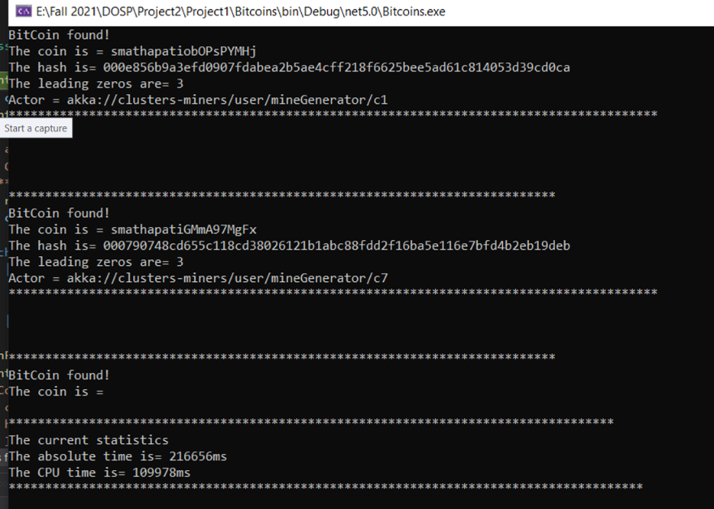

2. The result of running your program for input 4 – **CPU time to real time ratio is 0.41**

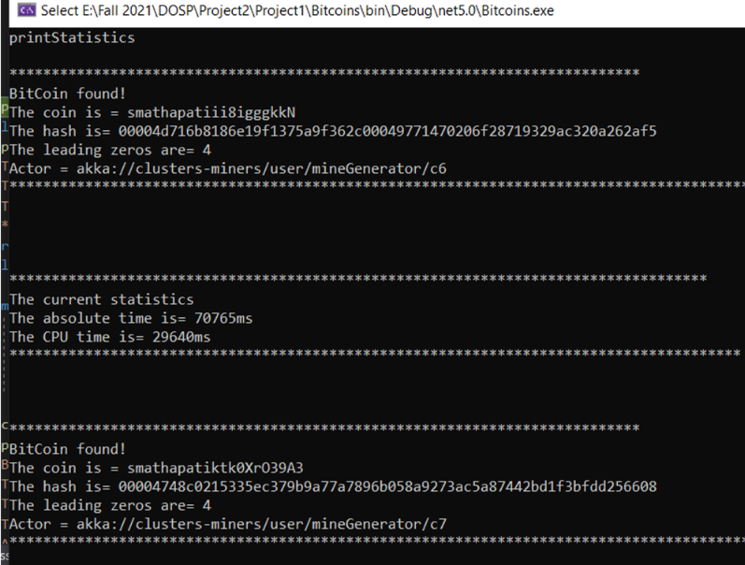

3. The running time for the above as reported by time for the above and report the time. The ratio of CPU time to REAL TIME tells you how many cores were effectively used in the computation. If you are close to 1 you have almost no parallelism (points will be subtracted). – **0.50**

4. The coin with the most 0s you managed to find. – **6**

5. The largest number of working machines you were able to run your code with. - **2**